**MAKE AUGMENTED REALITY APP USING UNITY**

This report was written to show the author responsibility while doing Field Work Practice program at

**PT.DUTA COMPUTER**

Period January 7th, 2019 until May 7th, 2019

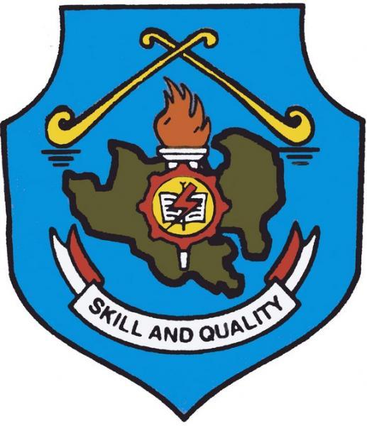

**MUHAMMAD KHALIL ALFARIZI**

**NIS : 17.7724**

**Skill Program : Information and Communication**

**Skill Competency : Computer and Network Engineering**

**EDUCATIONAL DEPARTMENT OF RIAU ISLANDS**

**VOCATIONAL HIGH SCHOOL 1 BATAM**

Jl. Prof. Dr. Hamka 1 Batu Aji – Batam. Phone (0778) 365903

2019